**Library is automated using Integrated Library Management System (ILMS)**

|  |  |
| --- | --- |
| **Description of library** | **2021-22** |
| Name of the ILMS Software | Library management software Created by college (library) Home Made |
| Nature of automation (fully or partially) | Library is automated OPAC Facility with 3 PC |
| Version | 1.0 |
|  |  |

An ILS comprises a relational database, software to interact with that database. Library Management System which is very easy to use and fulfils all requirement of a librarian.

1) General character:

* User friendliness: - Very easy to understand for a patrons as well as library staff.
* Windows Based or GUI (Graphical User Interface)
* Capacity to handle enormous records.
* Reliability
* Should give consistent Result.

2) New Technology:

* Network Capability.
* Interface for Internet connection.
* We have barcode printing as well as scanning Facility.
* OPAC ( online public access catalog)

OPAC is a computerized catalogue available to public. It is such type of cataloguing arrangement that is considerably more user friendly than a card catalogue since it provide a variety of help to the users, and can guide the users in s step by step manner in looking for information that he is seeking. Search is also possible at a remote terminal. It may be made available outside the library through Internet also.

Methods of searching OPACs:

1) Search by subject: Type subject name in search box after that you can got which books on specific subject available in college library.

2) Search by Author: This method is used for searching for works by a particular author.

3) Search by Title: T o search specific title.

4) Search by Publisher name: To search specific publisher’s books.

* Should use digital video camera for member’s photo generation.

3) Modules:

* Acquisition: The acquisition basically deals with selection and ordering of books and other library materials such as reprint of articles, standards, patents, thesis, conference proceedings, micro-fich, tapes, slides etc. and their subsequent procurement including processing of payment of bills. It also supports budget and expenditure monitoring by Department/Centre.
* Cataloguing: you can search.
* Circulation : The proposed system maintains

(i) Up-to-date membership records and

(ii) The latest status of collection meant for circulation. It performs all the functions related to circulation providing suitable checks at every stage. It takes care of infrequent, but routine functions such as bindery record management, display of recent additions, and so on.

* Serial Control: This system provides control on periodical subscription and subsequent monitoring of the scheduled arrival of individual issues.

4) Feature:

* Keep records of different Categories like; Books, Journals.
* Easy way to enter new books.
* Keep records of complete information of book like ; Book name, Author
* Name, Publisher’s name, Book purchasing date/Bill no.
* Easy way to make check-out.
* Easy way to make check-in.
* Automatic fine calculation for late returns.
* Different Criteria for searching book.
* Different kinds of reports like; total no. of books, no. of issued books, etc.
* Easy way to know how many books are issued to a particular student.
* Easy way to know the status of a book.
* And much more.

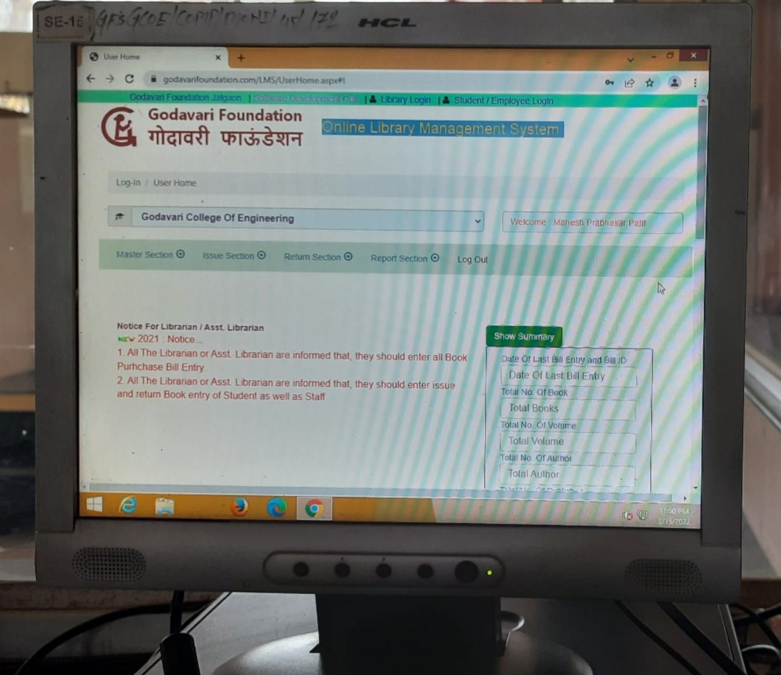

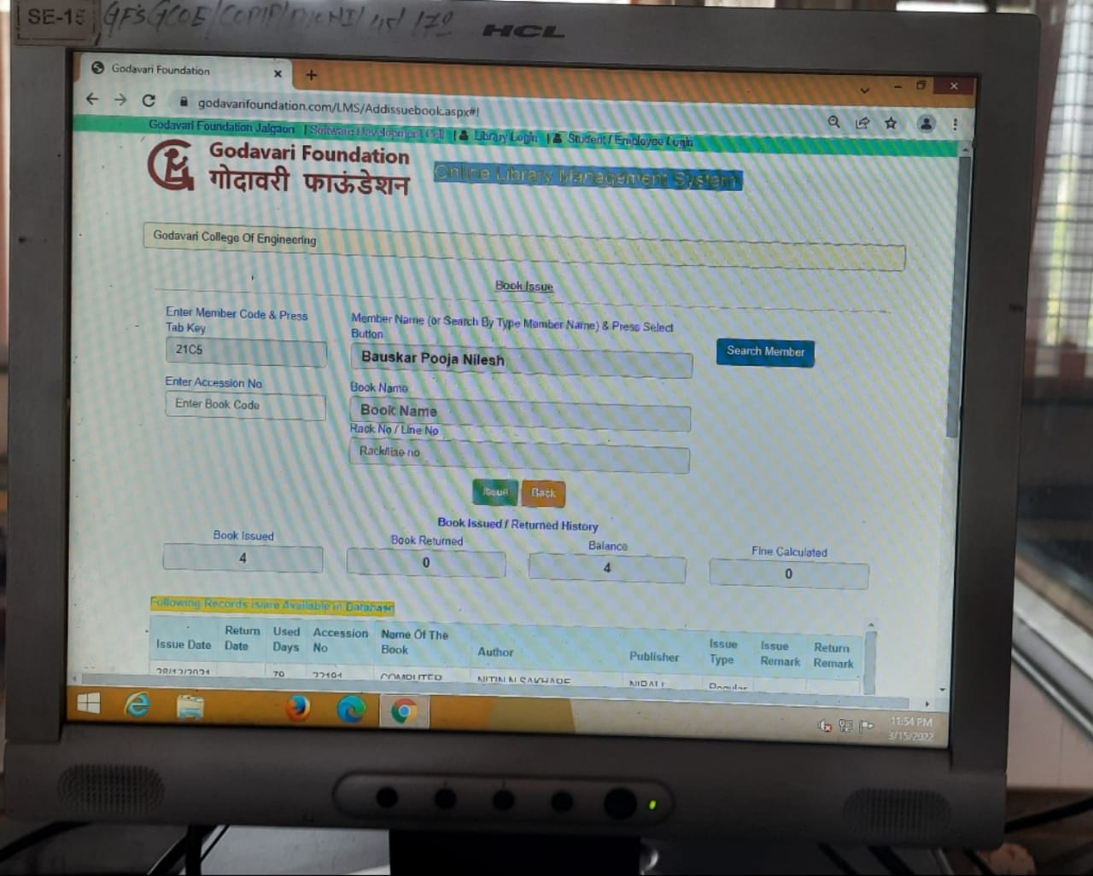

Manuscript Collection organized and described for patron use is an important prerequisite for a successful research. In the context of Library Science, a manuscript is defined as any hand-written item in the collections of a library or an archive. For example, a library's collection of hand-written letters or diaries is considered a manuscript collection. Such manuscript collections are described in finding aids, similar to an index or table of contents to the collection, in accordance with national and international content standards such as DACS and ISAD (G).

In other contexts, however, the use of the term "manuscript" no longer necessarily means something that is hand-written. By analogy a *typescript* has been produced on a typewriter. In book, magazine, and music publishing, a manuscript is an original copy of a work written by an author or composer, which generally follows standardized typographic and formatting rules. (The staff paper commonly used for handwritten music is, for this reason, often called "manuscript paper"). In film and theatre, a manuscript, or *script* for short, is an author's or dramatist's text, used by a theatre company or film crew during the production of the work's performance or filming. More specifically, a motion picture manuscript is called a screenplay; a television manuscript, a teleplay; a manuscript for the theatre, a stage play; and a manuscript for audio-only performance is often called a radio play, even when the recorded performance is disseminated via non-radio means.

Available books details

|  |  |  |  |  |  |  |  |
| --- | --- | --- | --- | --- | --- | --- | --- |
| Library Services: |  |  |  |  |  |  |  |
|  | Existing |  |  | Newly added |  | Total |  |
|  |  | No. | Value | No. | Value | No. | Value |
| Text Books |  | 6105 | 1620268 | 207 | 42395 | 6312 | 1662663 |
| Reference Books |  | 15976 | 4693007 | 13 | 11022 | 15989 | 46941029 |
| e-Books |  | 0 | 0 | 0 | 0 | 0 | 0 |
| Journals |  | 60 | 187000 | 0 | 0 | 60 | 187000 |
| e-Journals |  | 1springer | 210000 | 1 | 210000 | 1 | 420000 |
| Digital Database |  | 0 | 0 | 0 | 0 | 0 | 0 |
| CD & Video |  | 614 | 0 | 0 | 0 | 614 | 0 |
| Library automation |  | 0 | 0 | 0 | 0 | 0 | 0 |
| Weeding (Hard & Soft) |  | 0 | 0 | 0 | 0 | 0 | 0 |
| Others (specify) |  |  |  |  |  |  |  |
|  |  |  |  |  |  |  |  |

* Useful Information for Manuscript Submission:

The following information would be useful to receive with your submission:

**Title Information**

* Subject discipline Title if known (and subtitle, if any)
* **Primary Author Information** (provide for any coauthors as well)
* Name
* Position and affiliation
* Curriculum vitae
* Mailing address
* Work phone
* Mobile
* E-mail
* **Product Information**

Overview: Include a brief description of the publication’s objective and explain exactly what it will be about. How will your selection, organization, or treatment of the subject encourage readers to buy the publication? Table of contents: Include a table of contents indicating chapters and subdivisions within chapters Sample chapter: If available, please include a sample chapter. If you have published other articles and books, attach a list of those materials. **Market Information** Primary market: Indicate the audience(s) for this material (e.g., academic/research, graduate students, and professionals).

* Secondary market:

Competition: List publications that compete with or are similar to the one yopropose, describing their weaknesses and strengths and how your publication will be superior. Provide as much data on competitive products as possible (publisher, date written, price, page length etc.).

* **Manuscript Information**

Books: How many words do you anticipate to fully cover your topic? How many pages of appendices? Timetable: Please provide your best estimate for completing and delivering the final manuscript.

* Types of Manuscripts:
* Diaries
* Research Paper
* Speeches
* Photograph
* Encyclopaedias
* Autograph and commemorative albums
* Engineering objective books

**Central Library and Reading Room**

